Order Of Service

Singing: Psalm 119a—CW page 109

Reading: Psalm 150

Opening Hymn: TLH 545

Reading: II Peter 2:1-9

Request Hymn: CW Supplement 750

Reading: Luke 23:1-12

Sermon Hymn: TLH 383

Sermon Text: Song Of Solomon 3:2

Seeking But Not Finding # 2

Prayer

The Apostles’ Creed, TLH page 12

Holy Communion

The Lord's Prayer

The Blessing

Closing Hymn: TLH 46

* * * * * * * * * * *

Bible Study: Lambs: John 2:13-17; God’s House
Sheep: Proverbs 10:1-2; Your choice
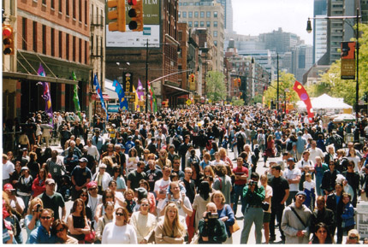

City Streets & Broad Places

Water
Of
Life

24 April 2016

W A T E R O F L I F E

Independent Christian Church—Conservative Lutheran Doctrine

Worship Service: 9:30 a.m. Bible Study: 10:45 a.m.

Larry Cooper, Pastor E-Mail address:
111 N. Ridge Road lcooper@wateroflife.cc
Coon Valley, WI 54623 Web Site:
Phone: (608) 452-2105 www.wateroflife.cc

* * * * * * * * * * * * * * * * * * * * * * * * * * *

Sermon Text: Song Of Solomon 3:2

Seeking But Not Finding # 2

* * * * * * * * * * * * * * * * * * * * * * * * * * *

Song of Solomon 3:2 I will rise now, and go about the city in the streets, and in the broad ways I will seek him whom my soul loveth: I sought him, but I found him not.

The Woman of Canaan

Matthew 15:21 Then Jesus went thence, and departed into the coasts of Tyre and Sidon.
:22 And, behold, a woman of Canaan came out of the same coasts, and cried unto him, saying, Have mercy on me, O Lord, thou Son of David; my daughter is grievously vexed with a devil.
:23 But he answered her not a word. And his disciples came and besought him, saying, Send her away; for she crieth after us.
:24 But he answered and said, I am not sent but unto the lost sheep of the house of Israel.
:25 Then came she and worshipped him, saying, Lord, help me.
:26 But he answered and said, It is not meet to take the children's bread, and to cast it to dogs.
:27 And she said, Truth, Lord: yet the dogs eat of the crumbs which fall from their masters' table.
:28 Then Jesus answered and said unto her, O woman, great is thy faith: be it unto thee even as thou wilt. And her daughter was made whole from that very hour.

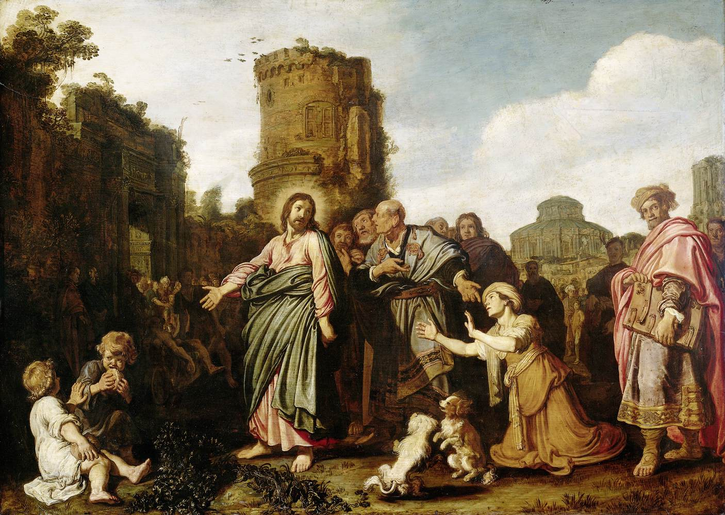

Song of Solomon 3:1 By night on my bed I sought him whom my soul loveth: I sought him, but I found him not.

3:2 I will rise now, and go about the city in the streets, and in the broad ways I will seek him whom my soul loveth: I sought him, but I found him not.

